Media Release September 19, 2024
Yarra Ranges Tourism
Euan McDonald-Madden
Head of Marketing & Communications
euan@yarrarangestourism.com.au
For interview contacts please see the end of this release

The beloved spring wine festival, Shedfest, is returning to the Yarra Valley next month. On Saturday 12 October and Sunday 13 October, fourteen members of the Yarra Valley Smaller Wineries Association will open their boutique, family-run cellar doors for wine-lovers to enjoy two days of tastings, carefully curated bites, lawn games, fire pits, stunning views and live music.
This year, two new wineries—Yileena Park and Helen's Hill Estate—are participating for the first time in the festival, while Six Acres and Seville Estate are also returning for the first time in several years.
Some wineries will also offer exclusive deals and experiences for guests, including Lawn Games at Sutherland Estate, a free family petting zoo at Tokar Estate, a classic car display at Steels Gate and kids colouring books at Yileena Park.
With over 100 Yarra Valley wines to try - including Sparkling, Rosé, Red, White, Orange, Pet Net and Dessert wines - there’s something for everyone to enjoy.
In addition to delicious drinks, each winery has curated delicious entrée-sized bites under $25 to accompany the relaxed experience, with menu offerings ranging from authentic Sicilian barbeque, Texan-style burgers, pizzas and calzones, Vietnamese Banh Mi and modern Thai cuisine. Kids and those with special dietary requirements won’t miss out either, with most wineries catering for both.
To make it accessible for every budget, the Association has changed the entry ticket to a flat rate of $35, rather than a day or weekend ticket.
More information can be found in the below press release.
If you are interested in chatting with any of the participating winemakers or would like to set up any photo/filming opportunities, please let us know.
Images can be found here.
Early bird tickets with 10% off are available to purchase now via shedfest.com.au with the code EARLYBIRD.





Shedfest is Back:
Uncork the Best of Boutique Yarra Valley Wineries This Spring
4 New Wineries, 14 Total | Live Music
Lawn Games | Bites | Family Friendly
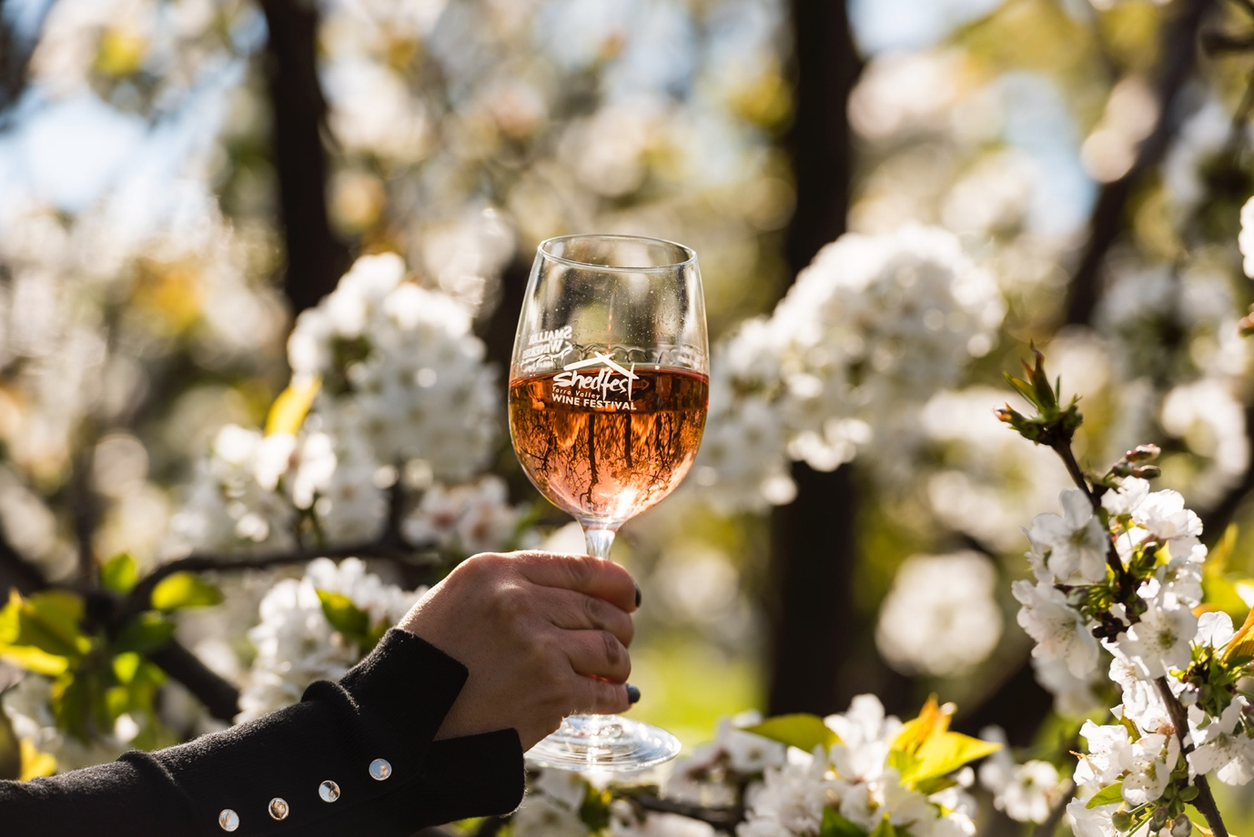

It’s time to gather your friends, family and even furry friends, because the beloved spring wine festival, Shedfest, is returning to the Yarra Valley next month!

On Saturday 12 October and Sunday 13 October, fourteen members of the Yarra Valley Smaller Wineries Association will open their boutique, family-run cellar doors for wine-lovers to enjoy two days of tastings, carefully curated bites, lawn games, fire pits, stunning views and live music.

This year, two new wineries—Yileena Park and Helen's Hill Estate—are participating for the first time in the festival, while Six Acres and Seville Estate are returning for the first time in several years.
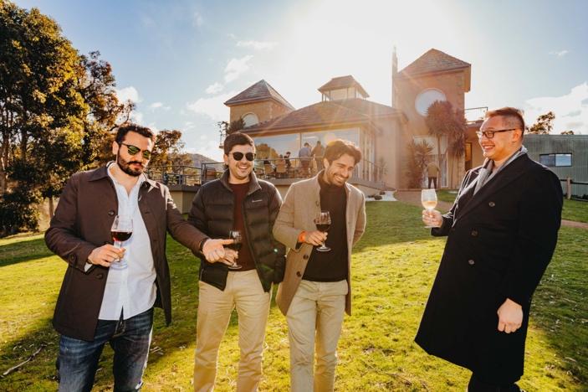

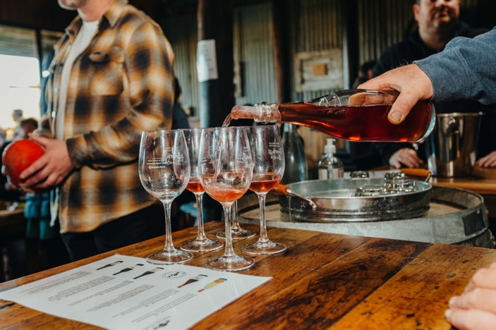

Some wineries will also offer exclusive deals and experiences for guests, including Lawn Games at Sutherland Estate, a free family petting zoo at Tokar Estate, a classic car display at Steels Gate and kids colouring books at Yileena Park.

The unique ‘festival’ experience showcases some of the best-kept secrets of the Yarra Valley and introduces event-goers to a delightful world of small-batch, minimal-intervention wines that represent the region at its purest.

The exciting line-up of the premium wineries participating includes:

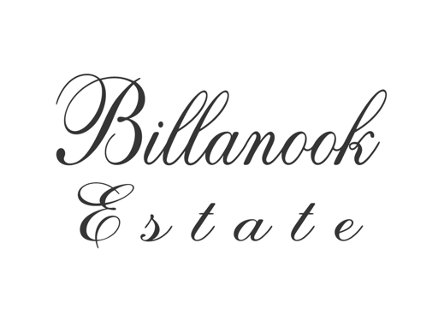

Owned and run by the D’Aloisio family, whose agricultural history and Italian heritage deeply influence their expert winemaking and culinary offering.
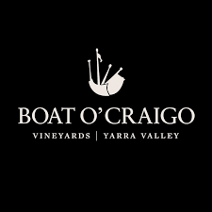

Founded and operated by two generations of the Graham family, offering exceptional single-site wines across a range of noble varieties.
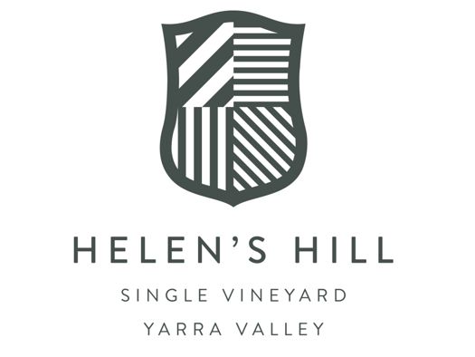

Helen's Hill is committed to making premium single vineyard wines, with minimal handling. They love farming, good food, and making great wine.
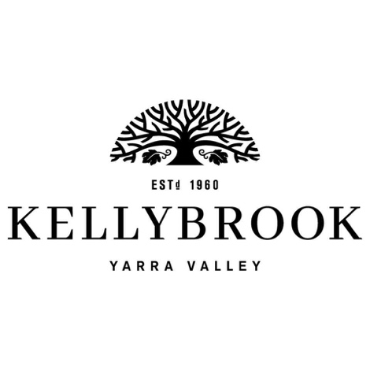

The first winery in the Yarra Valley region to open a cellar door, Kellybrook Winery is a family-run business. They take pride in producing everything - from wines, beers and ciders - in-house.
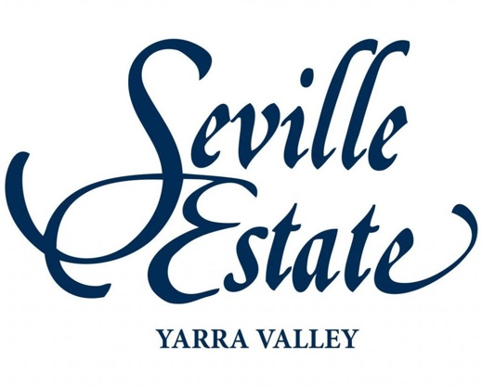

Founded in 1972 by Dr Peter and Margaret McMahon, Seville Estate has been at the forefront of the modern Yarra Valley wine movement for 40 years.
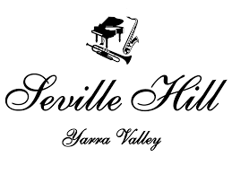

The D’Aloisio family is known for its elegant fruit-driven red wines. The Seville Hill winery produces such wines amongst stunning cherry orchards.
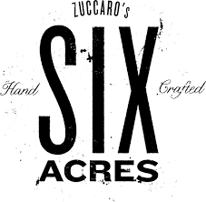

Nestled in the southern hills of the Yarra Valley, Six Acres boutique winery and vineyard is owned and worked by the Zuccaro family.
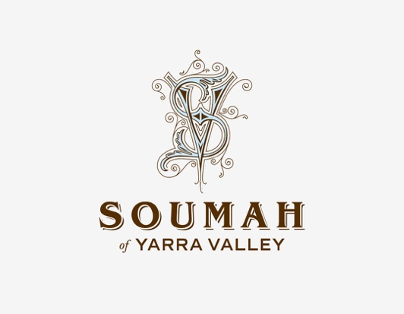

Soumah is a family-owned winery inspired by Italian life, wine and food. From a winemaking perspective, the team at Soumah believe the terroir of Gruyere is similar to northern Italy.


Owned and run by Matthew Davis, Brad Atkins and their son Sebastian, Steels Gate produces refined wines including Iberian varietals using minimal intervention and natural practices.
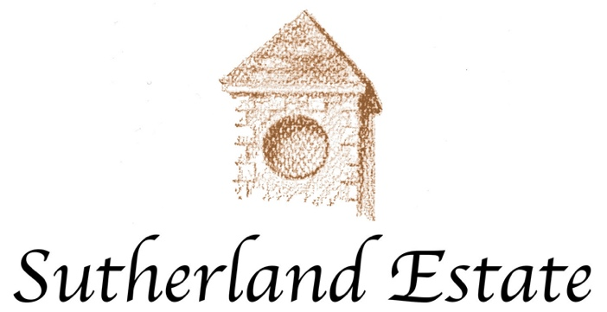

Founded and operated by ex-ballerina Cathy Phelan and ex-barrister, Angus Ridley, Sutherland Estate produces stunning small-batch wines from vines that drape down a large, scenic valley.
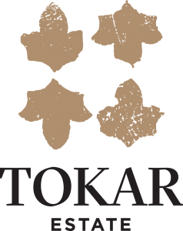

The Tokar family has owned and operated their picturesque Mediterranean-inspired cellar door and winery for almost 30 years and is renowned for planting some of the first Tempranillo vines in the Valley.
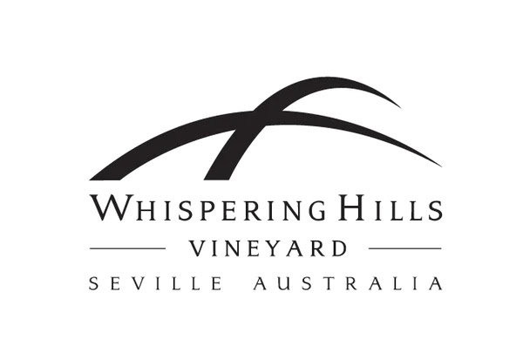

Established in 1985, the Lyons family has produced elegant cool, climate wines for over twenty vintages - including their exceptional sparkling wines.
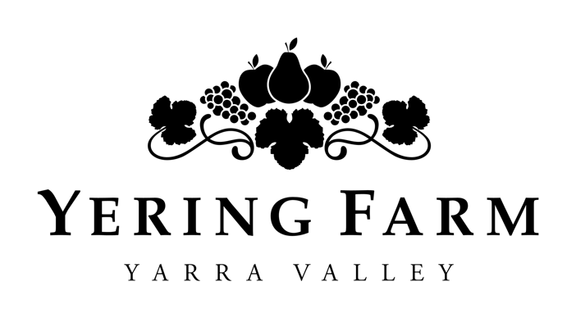

Owned and operated by the Johns family, Yering Farm was first established in the 1800s by a family of French/Swiss vignerons, in which some of the Johns family’s acclaimed vines have been cloned.
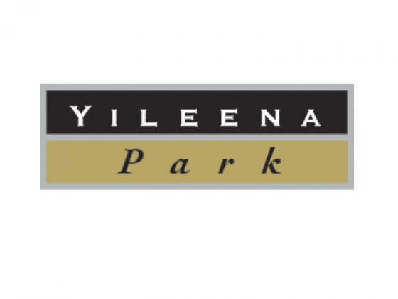

Yileena Park is a small boutique Cellar Door, Winery and Vineyard. Fine-aged wines are the hallmark of the property, which are best enjoyed by the fireplace in the cellar door alongside a cheeseboard.
The participating wineries each boast unique stories and specialities, from their winemaking techniques (whether it's old-school or new wave) and entry into viticulture, to their favourite drops and opinions on where Australian winemaking is heading. Whatever it might be, there’s something deeply personal you’ll learn from every one of them over the weekend.
Even the most novice wine drinkers will learn something new about wine as they get a chance to taste over 100 wines at the event, with some wineries offering new and vintage releases exclusively over the weekend.

With Sparkling, Rosé, Red, White, Orange, Pet Net and Dessert wines - and even ciders and beers on offer - there’s something for everyone.

In addition to delicious drinks, each winery has curated delicious entrée-sized bites under $25 to accompany the relaxed experience, with menu offerings ranging from authentic Sicilian barbeque, Texan-style burgers, pizzas and calzones, Vietnamese Banh Mi and modern Thai cuisine.

Kids and those with special dietary requirements won’t miss out either, with most wineries catering for both.

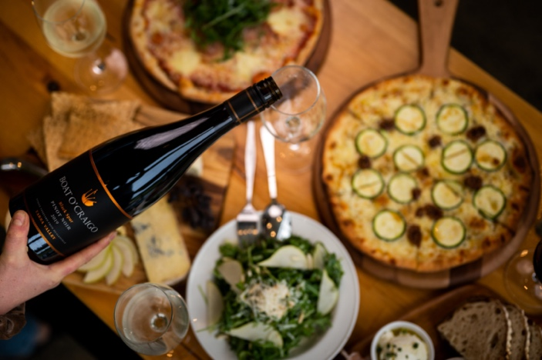

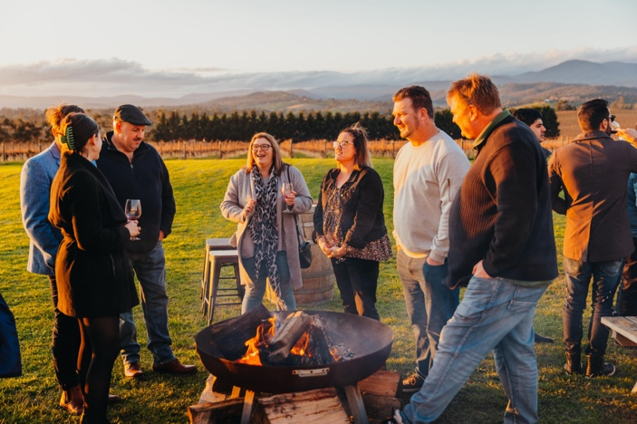

With so much on offer, you can design your itinerary by wine varietals, menus, or even dog-friendly venues.

To make it accessible for every budget, the Association has changed the entry ticket to a flat rate, rather than a day or weekend ticket.

The types of tickets available this year include:
Entry tickets are $35 per person, which gives wine lovers access to tastings at participating wineries over the weekend (Saturday AND Sunday), in a complimentary tasting glass they get to keep.

Wine & Dine tickets are $70 per person, which provides access to tastings at participating wineries over both days, 1 x tasting glass to keep, 1 x glass of wine (redeemable once), and 1 x meal voucher (redeemable once).

VIP tickets are $100 per person, which provides access to tastings at participating wineries over both days, 1 x tasting glass to keep, 1 x glass of wine (redeemable once), 1 x meal voucher (redeemable once) and 1 x bottle of wine (redeemable once to the value of $35).
Kids, non-drinkers and designated drivers have free entry.
In addition to the best value ticket in town, patrons can enjoy the fact that they are contributing to local community groups, with the YVSWA raising well over $100,000 towards groups including the local CFA and SES, as well as Make-A-Wish Australia.
Visit www.shedfest.com.au for tickets and more information on the wineries, menus and activities.

- ENDS -

Menu Summary, Dog-Friendly Venues and More:

Winery | Menu | Activities
Billanook Estate | Italian Meatball Panini:  Hand-rolled meatballs, tomato passata, topped with a salsa verde on freshly baked ciabatta bread. - $18  Gnocchi: Homemade Ricotta Gnocchi pan seared with a choice of a traditional Napoli pomodoro sauce or a Picante Gorgonzola cream sauce - $18 (V) (GF avail on request)  Al Dente’s Cannoli: Delicate tubes of golden crunchy pastry filled with fresh delicious and authentic flavoured Ricotta filling - $8 | Kids meals  Coffee & tea  Cheese boards  Live music on both days
Boat O'Craigo | The Tipsy Sicilian charcoal barbeque: $18-$24  Dusted Flathead Tails with zest lemon mayo (GF)  Pork and Fennel Sausage with Cunliffe and Waters Beetroot and Orange relish (GF)  Swiss brown mushroom (lge) stuffed with Cunliffe and Waters Beetroot and Orange relish and topped with Pecorino cheese (GF, V, Vg on req)  All are served with rocket, fennel, red cabbage, radish, and orange pieces with a lemon & oregano vinaigrette | Gourmet Pizzas  Kids pizzas  Desserts  Artisan cheese boards available  Live Music on both days  *Dog Friendly*
Helen's Hill Estate | Sliders all served with chips - $25  - Slow-roasted mushroom with goat cheese and tomato (Veg)  - Pulled pork with homemade BBQ sauce and creamy slaw  - Corn beef, sauerkraut, swiss cheese and Russian dressing | Gourmet Pizzas  Kids Meals  Artisan cheese boards  Desserts  Live music  * Dog Friendly *
Kellybrook Winery | Slow-cooked lamb with house-pickled beetroot, slaw, rocket and pomegranate molasses dressing in sourdough baguette (DF) - $20  Hot baked potato with butter, sour cream, cheese, coleslaw (GF):  - With roasted capsicum and chives - $17  - With crispy bacon or hot-smoked salmon - $20  Vegan available  Rich chocolate cake with berries and cream - $15 | Kids' toasties  Cheese boards and charcuterie boards  Live music 1-4pm both days  Lawn games on the oak tree lawn  * Dog Friendly *
Seville Estate | Grilled Gold Street dairy ‘Jersey Cheese’ - olive oil, apple balsamic on Spelt Flatbread with fennel pollen - $22  Stone Axe Wagyu Bacon Skewers, with chimichurri, potato skins, aged cheddar sour cream, wild garlic - $24  Strawberries & Cream vanilla parfait with strawberry jelly, wood sorrel - $16 | Kids Cheese Burger, french fries  Ice cream sundae - $18  * Dog-friendly *
Seville Hill | Hand Made Fusilli Pasta with Prawns, Cherry Tomatoes, EVOO, Seville Hill Chardonnay, Garlic, Fresh Chilli and Parsley - $25  Pasta Primavera - Hand Made Fusilli Pasta, Asparagus, Sugar Snap Peas, Garlic Butter, Parmigiano Reggiano and Fresh Italian Herbs (Vegetarian) - $20  Basque Cheesecake, cream and fresh berries - $15 | Kids meals  Coffee  Cheese boards  Live Music - Jazz  * Dog Friendly *
Six Acres | Authentic Charcoal Sicilian Sausage ( pork, sundried tomatoes, pecorino and fennel seeds), on a chickpea, pickled zucchini and salmoriglio salad - $20. GF  Charcoal Sicilian Eggplant on a chickpea, pickled zucchini and salmoriglio salad - $20 (V)  Blood orange and almond cake with whipped ricotta - $10 | Music  Wine sales  *Dog Friendly*
Soumah | Potato Pizza -$20  Wood-fired pizza with confit garlic and chickpea base, roasted potato, red onion, green olives, fior di latte  d’Soumah Pizza -$20  Wood-fired pizza with San Marzano tomato base, wood-smoked ham, artichokes, green olives, white anchovies, fior di latte, pine nuts  Chocolate Florentino - $10  Chocolate fudge brownie, almond honey crust, house-made caramel ice cream | Kids meals  Coffee  Cheese and antipasti boards  Live music  *Dog-friendly*
Steels Gate | Combination skewer (chicken, pork, beef & fish) with tamarind & palm sugar sauce - $10 (2 per serve)  Stir fry crispy pork belly with Chinese broccoli & oyster sauce - $25  Papaya salad with Jim jaew sauce - $18 with grilled pork - $25  Roti with banana, condensed milk & chocolate $15 with ice cream $18 | Classic Car display - bring your own!  Live Music 12-4  *Dog Friendly
Sutherland Estate | Short Rib Beef Bourguignon, potato salad, bacon and herbs - $25  Pumpkin, spinach, pesto and ricotta lasagne, Persian fetta, cherry tomatoes - $22  Frosty's glorious sticky date, butterscotch sauce and vanilla ice cream - $15  Cheese Boards - $25 | Live music  Lawn Games  *Dog Friendly *
Tokar Estate | Southern Fried Chicken Burger - $19  Fried Chicken, shredded lettuce, cheese, and mayo on a warmed bun  Choose your spice level: mild/hot/extreme  Smoked Mushroom and Haloumi Burger - $19  Smoked mushrooms, grilled halloumi, pesto, fennel salad  (Gluten Free, Vegetarian, Vegan options available)  Pulled Pork Croquettes - $17  Served with tomato relish and fennel and apple slaw | Kids meals  Hot Jam donuts  Cheese boards available  Live band  Lawn Games  Petting zoo for families  * Dog Friendly *
Whispering Hills | Parsnip soup with burnt curry leaf butter, crouton + spring herbs - $10  (Veg + GF option)  Texan-style pork ribs smoked low and slow with hand-cut slaw + potato salad + house-made pickles - $25  (GF)  Rustic Farmhouse Lemon Curd Roulade - $10 | Espresso Coffee & Tea  Live Music  Dog Friendly  (On Leads)
Yering Farm Wines | Homemade Hot Apple Pie Made with Yering Farm's own Granny Smith Apples served with a good dollop of cream and fresh fruit  $15  Pruners Platter -  A selection of local cheeses, cornichons, quince paste, fresh fruit and crackers  $15 | Live Music  Coffee van  Dog Friendly
Yileena Park | Bahn Mi menu: (All cold cuts)  Smoked chicken Bahn mi:  Our smoked chicken meat, pâté, pickled carrot/radish, smoked chilli mayo and coriander on a baguette - $18  Smoked Moroccan pork Bahn mi:  Moroccan pork meat, pâté, pickled carrot/radish, smoked chilli mayo and coriander on a baguette - $18  Asian marinated tofu Bahn mi:  pickled carrot/radish with vegan chilli mayo and coriander on a baguette (Vegan/vegetarian option - have to confirm baguette is vegan) - $16  Cheese plate:  Our smoked cheddar, smoked blue cheeses, with fig and ginger jam, crackers - $12 | Music  Kids colouring in sheets and pencils

About The Yarra Valley Smaller Wineries Association

Over the years, the reputation and popularity of the Yarra Valley has grown deservedly. Determined not to be overshadowed, a group of smaller wineries banded together several years ago to create the Yarra Valley Smaller Wineries Association – a not-for-profit group whose combined range extends to several different styles, from the handcrafted Chardonnay, Pinot Noir, Cabernet, and Shiraz for which the Yarra Valley is celebrated, to other styles such as Sparkling, Rose and Fortified wines.

All the wineries in the group are open on weekends and public holidays with some open 7 days. They are host to or support various events throughout the year including the group’s ‘Shortest Lunch’ held in June and 'Shedfest' in October, held over the year’s shortest weekends.

Through these events, the group has pledged enormous from the events, contributing over $100,000 to local community groups including the CFA, Schools and local Clubs.

So get in your car with the spirit of discovery, grab a map and explore some of the quieter yet highly rewarding wineries in the Yarra Valley – you’re in for a pleasant surprise.

Media contacts:
Elia Lom
Tracado Pty Ltd
E: elia@tracado.co
M: 0411 211 939

McKenna Moroz-Johnson
Tracado Pty Ltd
E: mckenna@tracado.co
M: 0431 781 445
Talent:
Daniel Tokar – President at YVSW and Owner of Tokar Estate
Matthew Davis - Vice President at YVSW and Owner and Vigneron of Steels Gate
John D’Aloisio – Event Director at YVSW and Owner of Seville Hill

